**Battle of the Bands**

**Story**

*A new era dawns over the land! The two queens of neighboring kingdoms have each given birth to a child: the royal baby who represents a new age of prosperity for each of their lands! “Which is why the child must die,” each kingdom hushedly whispers amongst themselves, eyeing the other kingdom’s newborn. The kingdoms’ armies rally and set out to kill the enemy child--and anyone who stands in their way. So too do the mothers prepare for war, as they will go to any lengths to keep their child close and protect them from the violent hordes.*

*The great land of the warring kingdoms will see no peace until one of the newborn children is dead. The only question is: which will die, and which will survive?*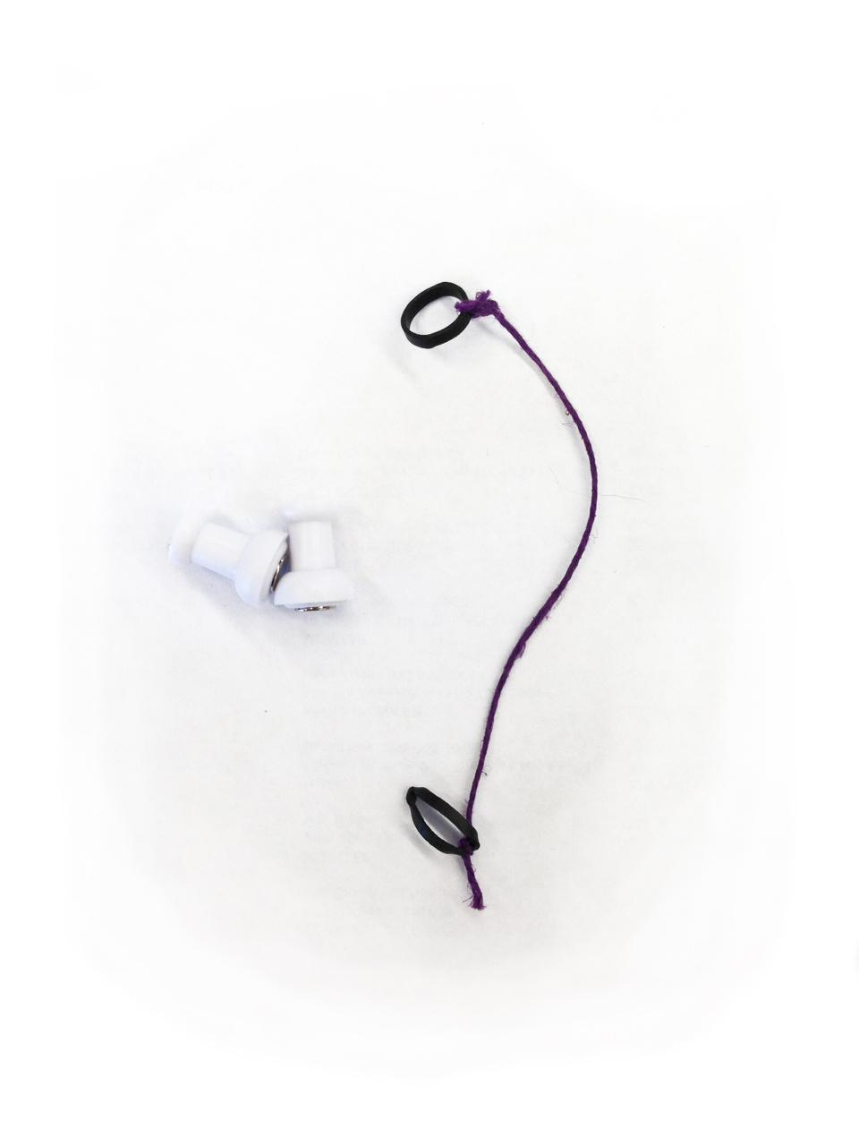

**Materials:**

* 17 pin magnets per player
* 15 rubber banded strings per player
* a white board
* dry erase marker

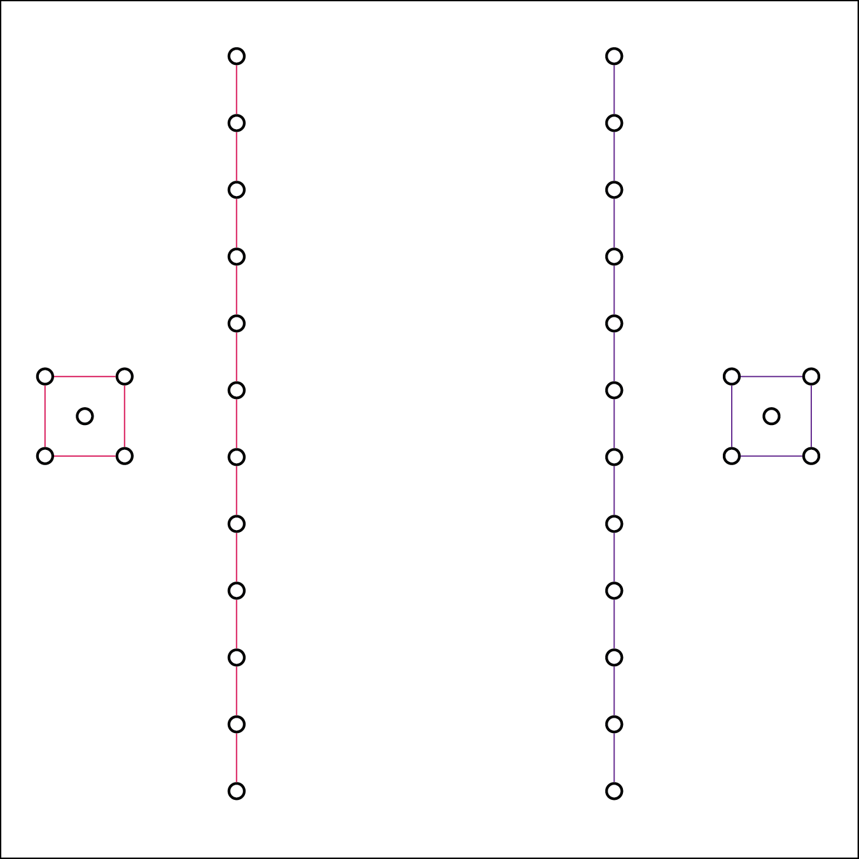

**Setup:** (refer to the diagram to the right)

1. Draw a 3’ by 3’ square on a whiteboard using an expo marker
2. Loop the rubber bands twice around the magnet to create connections. Repeat as needed until you have a square of four pins and a long line.
3. Place the chain of **12** magnets and the square on the game board as shown in the image to the right.
4. Each player puts one pin inside their square.

**Characters:**

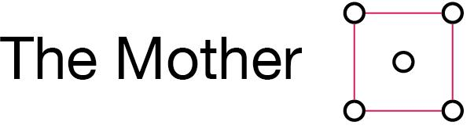

* The Mother is the last line of defense between your opponent’s soldiers and your baby. While under the protection (inside) of their Mother, a baby cannot be killed.
* When the Mother is reduced to three nodes, reconnect to create a three sided shape.
  + if you need to move one of the nodes to reconnect the shape, this does not count as a move.
* The baby becomes vulnerable to kill when the Mother is reduced to only two nodes.
* The Mom may not reconnect with the soldier pieces.



* The Baby cannot move on its own. He/She relies on the Mother for the movement.
* When the Mother moves, the Baby may move to anywhere inside that area without using one of your three moves.
* When the Baby is killed, the game is over.



* The Soldiers are the basic offensive unit in the game.
* At the cost of one of your three moves, you may connect/disconnect your strand
* A single Soldier node cannot move on its own--it can only sit and wait to either be killed by the opponent or re-connected to one of your Soldier lines.

**Gameplay:**

The goal of the game is to navigate around the board using your Soldiers and Mom to kill your opponents baby while defending your own. In order to win, a player must break through the defense of the opponents Mom and kill their Baby. At the start of the game, setup the board referencing the guide above and then choose a player to go first.

**On your turn:**

* You can perform up to three actions in a single turn. After three actions, it becomes the other player’s turn. For each action, you may “Move” or “Connect/Disconnect.”
* **To Move**: pick up or slide any magnet to any location without moving any of the other pins.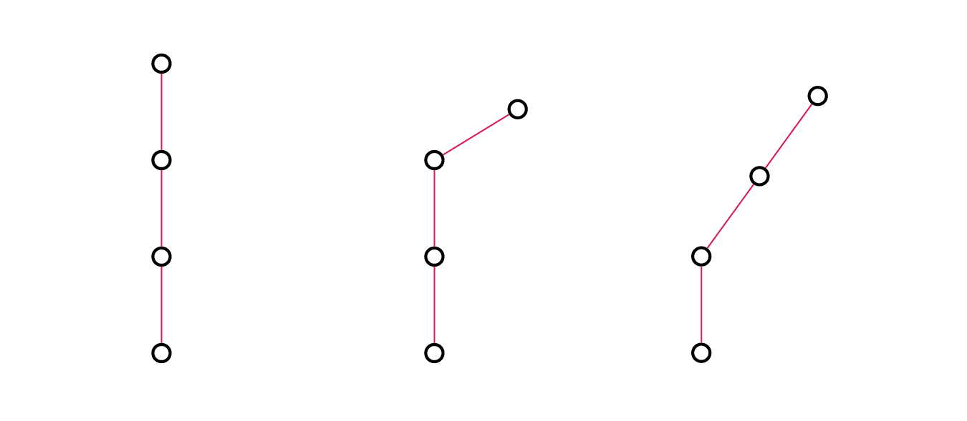
  + You may cross over strings
  + No move can adjust the location of any other magnet. The only exception is when the Baby moves with its Mother.
  + No move may exit the boundaries of the drawn board.
* **To Connect/Disconnect:** split your Soldiers into small squads or reconnect into a larger strand.
  + Each connection/disconnection costs you one of your three moves.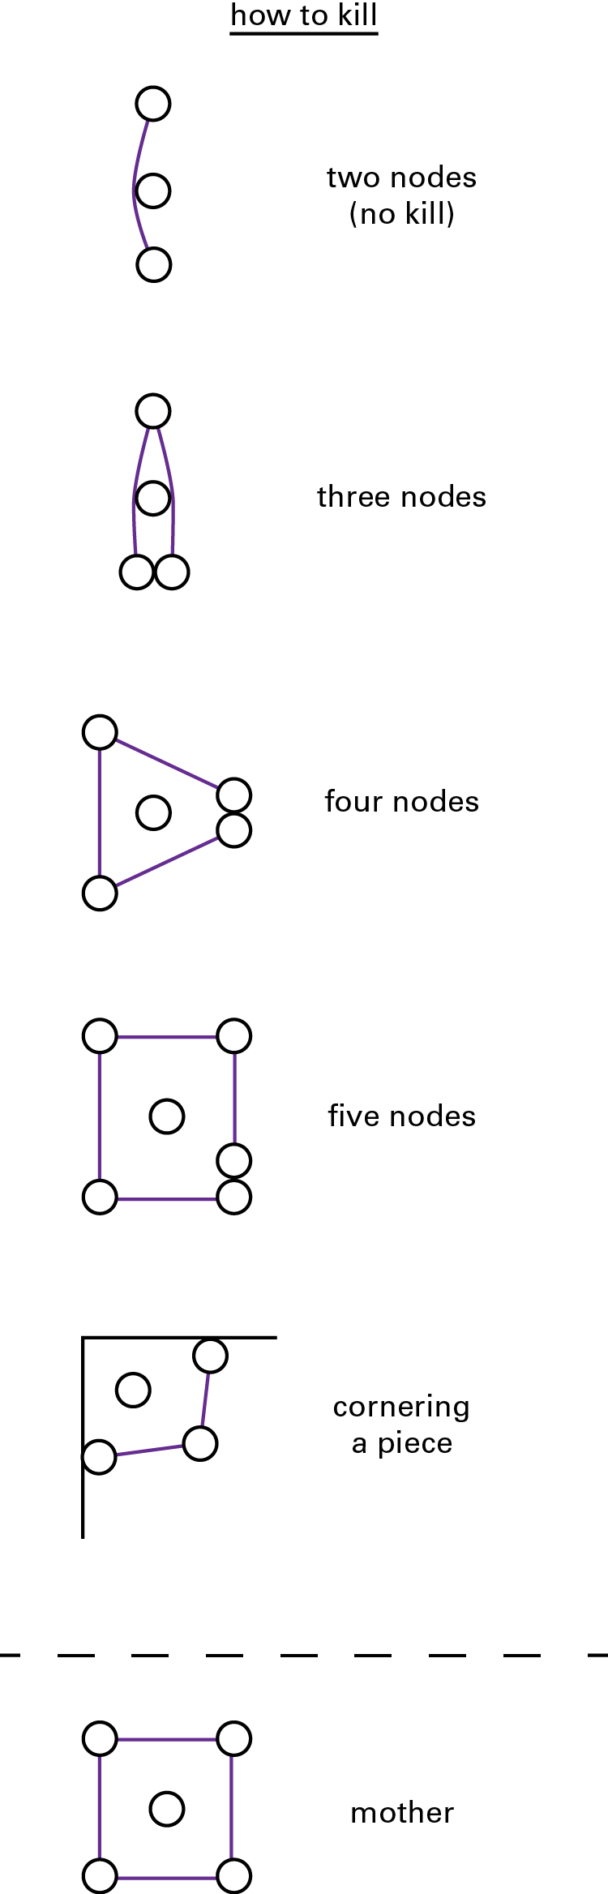
  + To disconnect: remove the connection between two magnets without moving any of the nodes.
  + To connect: add a connection between two magnets without moving any of the nodes.
* **To Kill:** You must completely encompass enemies node(s) with your own. Use the image to the right as reference for killing opponent nodes. Note that you can use the boundaries of the board to complete a surround.
  + If you kill any of your opponents Solider, remove that node and it’s corresponding connection.
  + If you kill a node on your opponents Mother, remember to reconnect the shape (you may move the nodes closer with necessary).